Week: 4
Worksheet Experiment: 2
“To Observe Osmosis in Potato Strips”
GROUP 5: Syed Sualeh Abbas 10303.
Lab Performance (10 Marks):
Total Marks (20 Marks):
- Observations (10 marks):
- Length:
Salt Concentration (gm/100 ml) | Initial potato strip length (cm) | Final potato strip length (cm) | Change in length  (cm) | Avg. Change in length | Observations  (Change in texture)
0 | 2 | 2.1 | 0.1 | 0.15 | Hardest
0 | 2 | 2.2 | 0.2 | 0.15
1 | 2 | 2.0 | 0.0 | 0.1 | Harder
1 | 2 | 2.2 | 0.2 | 0.1
2 | 2 | 2.2 | 0.2 | 0.2 | Hard
2 | 2 | 2.2 | 0.2 | 0.2
3 | 2 | 2.3 | 0.3 | 0.2 | Soft
3 | 2 | 2.1 | 0.1 | 0.2
4 | 2 | 2.0 | 0.0 | 0.05 | Softer
4 | 2 | 2.1 | 0.1 | 0.05
5 | 2 | 2.2 | 0.2 | 0.2 | Softest
5 | 2 | 2.2 | 0.2 | 0.2
7 | 2 | 2.1 | 0.1 | 0.1 | Softest
7 | 2 | 2.1 | 0.1 | 0.1
- Weight:
Salt Concentration (gm/100 ml) | Initial weight of potato strip (gm) | Final weight of potato strip (gm) | Change in weight  (gm) | Avg. Change in Weight
0 | 2.54 | 2.74 | 0.2 | 0.165
0 | 3.06 | 3.19 | 0.13 | 0.165
1 | 2.8 | 2.19 | 0.11 | 0.08
1 | 3.02 | 3.07 | 0.05 | 0.08
2 | 3.01 | 2.98 | -0.03 | -0.01
2 | 3.02 | 3.00 | -0.02 | -0.01
3 | 2.88 | 2.84 | -0.04 | -0.015
3 | 2.85 | 2.78 | -0.07 | -0.015
4 | 2.7 | 2.54 | -0.16 | -0.11
4 | 2.89 | 2.83 | -0.06 | -0.11
5 | 2.74 | 2.66 | -0.08 | -0.085
5 | 2.98 | 2.89 | -0.09 | -0.085
7 | 2.778 | 2.7 | -0.08 | -0.125
7 | 2.9 | 2.73 | -0.17 | -0.125

2) Graphical Representation (5 marks):
- Draw a graph between the Average change in length on the y-axis and salt concentration on the x-axis.
- 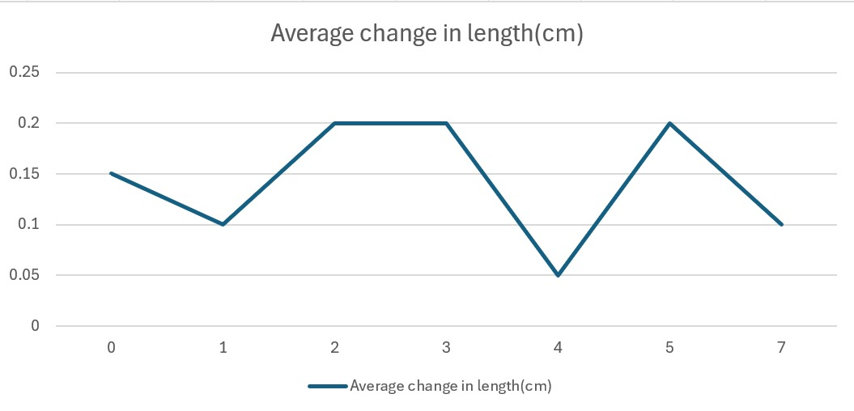
- Draw a graph between the Average change in weight on the y-axis and salt concentration on the x-axis.
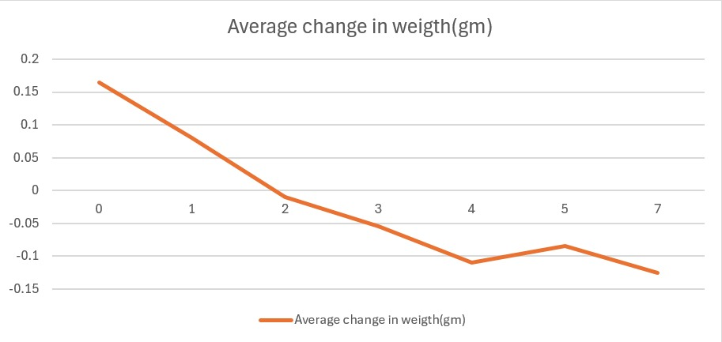

3) Results (3 marks):
OUR RESULTS BASED UPON GRAPH AND READINGS:-
Change in Weight:- The average change in weight calculation was all okay, which tells us that while the potato was in hypotonic solution it gained the weight, because the water entered the potato, which means that, there was more salt in potato than the water. At 1.99gm/100ml, there was no water entering the potato that means it was the isotonic range of the potato. After that, the potato started to lose water which means the potato was in hypertonic solution and the water is moving outwards through osmosis.
Change in Length:- The change in length should also be decreasing linearly, but the issue we faced was that our graph was not linear which means we potentially made errors while recording the readings (i.e. Problems are written in problem section). As for Hypotonic solutions the 0gm/100ml the change in length of potato stick was maximum which means it gained water. The length is changed because when cells gain water they basically get a bit larger in volume hence causing rise in length. After that, in isotonic ranges, the length should neither be increasing nor be decreasing. Because no water enters or leaves the cell. And as for hypertonic ranges, the average change in length should be in negative.
RANGES:-
0.0-1.89: Hypotonic solution
1.9: Isotonic solutions.
2.0-5.0: Fairly hypertonic solutions
5.0-7.0: Extremely hypertonic solutions.

4) Questions (2 marks):

- Explain at which range of salt concentration the solution was hypotonic and hypertonic. How do we identify the isotonic range in a graph? What was your group's isotonic value according to the graph?

ANS:- The range of hypotonic solutions was from 0gm/100ml to 1gm/100ml. that’s because in that range the water entered the potato and potato change in weight was positive. From 2gm/100ml to 7gm/100ml it was hypertonic as potato lost some weight which means that water moved out of the cell.
We can easily identify the isotonic range where the graph touches the intercept, and change in weight is zero. For our group, it was 1.999gm/100mlwhich is nearly 2gm/100ml.

- In regions with high soil salinity, farmers sometimes struggle with crop yields. Based on your experiment, explain why plants might have difficulty absorbing water from saline soils. What solutions might you suggest to mitigate this problem?
ANS:- In Saline soils, the concentration of soils is very high compared to plants roots, so instead of water moving in the roots, the water of roots move in the soil, which may cause storage of water in plants roots. In extreme cases, plants cannot absorb any water at all, even if the soil looks moist, because the water potential is too low (salt binds water molecules).
5) Problem:
1. One of the problems due to which we might have gotten wrong readings for length was that all potato sticks were not EXACTLY of same length (human error) and the change of length recorded of initially dependent upon their sizes which led us to wrong readings. The potatoes increase according to their size, so they were all supposed to be of same sizes. There is a broad change in our initial length values which led us to wrong answers. Now the question rises, whatever the size was, the change in length and its average should be constant, YES, it is possible, and here comes the second problem….
2. We might have calculated the wrong final values of length. Because we did not have the perfect tool for measuring small lengths, might be possible we did not record the exact change in length which led us to wrong answers.
3. Because our readings of weight is alright that means that our solutions were prepared alright. So first two are our potential problems.

